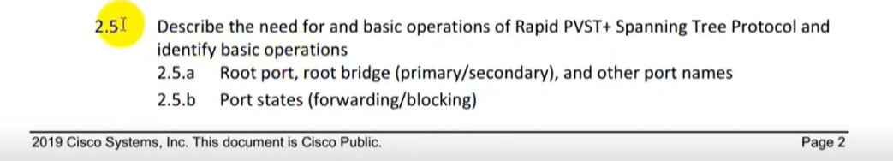

**STP (Spanning Tree Protocol)**

* For backup purpose and fault tolerance, we usually create redundant links.
* Redundant link preventing entire network down situation from single link failure.
* Redundant link can create network loops that flood down frames in the network.
* STP automatically removes layer 2 switching loops by shutting down redundant links.
* Spanning Tree Protocols (STP) is a protocol, it actively monitors all links of the network.
* Cisco Switch flooding frame unknown unicasting, multicasting and broadcasting.
* If there any redundant link available in the network that can cause Layer 2 loop.
* Layer 2 loops in the network can cause problem unnecessary resources utilization.
* Multiple frame transmission, unstable MAC table & unnecessary frame lookup by host.
* To finds a redundant link, it uses an algorithm, known as STA (spanning-tree algorithm).
* Spanning Tree Protocols used STA (Spanning Tree Algorithm) to prevent Layer 2 loop.
* STA detecting layer 2 loops and block it until first one link goes down or disconnected.
* Spanning Tree Protocols is a link management protocol that provides path redundancy.

**Redundancy:**

* Redundancy, Failover, High Availability, Clustering, RAID and Fault-tolerance.
* A good network design provides the redundancy in devices and network links.
* Redundancy is basically extra hardware or software that can be used as backup.
* If the main hardware or software fails or link fail or unavailable in case of emergency.
* It is method for ensuring network availability in case of network device or path failure.
* It is method for ensuring network availability in case of network device unavailability.
* Network redundancy is process through which additional or alternate instances of network
* devices, equipment & communication mediums are installed within network infrastructure.
* Redundancy can be achieved via failover, load balancing & high availability in automatically.
* High availability is a feature which provides redundancy and fault tolerance automatically.
* High Availability is a number of connected devices processing and providing a services.
* The goal is to ensure this service is always available even in the event of a failure or down.
* Clustering is similar to redundant servers & provides fault tolerance in case of emergency.
* Eg. Two power switches of networking devices in case one goes down other main the network.

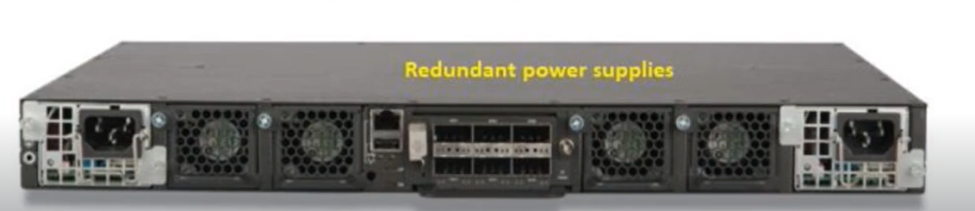

**Advantages Of STP:**

* Broadcast Strom
* Mac Address instability
* Multiple Frames transmission

**Broadcast Strom:**

* When Switch receives broadcast frames, it continues broadcasting them.
* The Switches broadcasting them again to its other interfaces or ports.
* Broadcasting will keep going on forever until you shutdown the network.
* This phenomenon or situation is called a broadcast storm of Switches.
* The Broadcast storm consumes the entire bandwidth of the network.
* The Broadcast storm denies bandwidth for normal network traffic.
* The Broadcast storm can shut down entire network in seconds or less.
* The Broadcast storms start small but like snowball end up being very big.

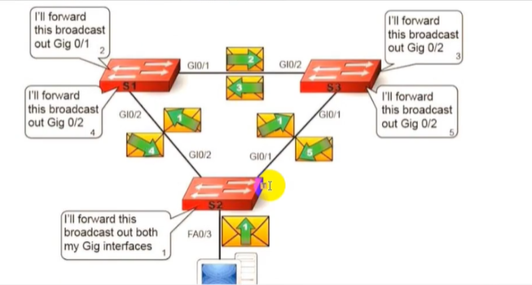

**MAC Address Instability:**

* MAC tables are built by examining the source MAC address on a packet received.
* The source MAC address is tied to the interface or port it was received on.
* If loop occurs, then same source MAC address could be seen on multiple interfaces.
* Looped in the network can make MAC Address Table or CAM table unstable.
* Instability of MAC table causes copies of same frame to be delivered to multiple ports.
* MAC instability results multiple copies of a frame arrive on different ports of a switch.

**Multiple Frame Transmission:**

**Types Of STP:**

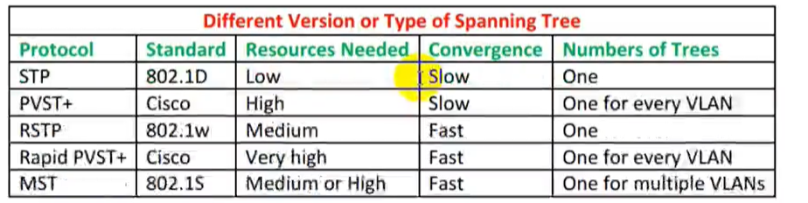

**PVST+ (Per-Vlan Spanning Tree Plus):**

* PVST+ is term which stands for Per-VLAN Spanning Tree Plus (PVST+).
* PVST+ is a Cisco implementation Of Spanning Tree Protocols (STP).
* Per-VLAN Spanning Tree+ (PVST+) is an extension Of the PVST standard.
* PVST+ supports Dot1Q trunking encapsulation while PVST not support.
* PVST+ provides separate Spanning-Tree instance for each VLAN in network.
* PVST+ run a Spanning-Tree instance per VLAN (Virtual Local Area Network).
* PVST+ provide each VLAN have its own Spanning Tree Protocol topology.
* PVST is usually the default Spanning Tree Protocol (STP) on Cisco Switches.
* PVSTP+ take 30 to 50 seconds to transit from blocking state to forwarding state.

**RPVST+ (Rapid Per-Vlan Spanning Tree Plus):**

* RPVST+ is term which is stands for Rapid Per-VLAN Spanning Tree Plus.
* Rapid PVST+ (IEEE 802.1w) is an enhanced version of the PVST+ version.
* Rapid PVST+ allows for faster Spanning-Tree calculations and convergence.
* RSTP is typically able to respond less than 10 seconds of a physical link failure.
* Rapid PVST+ defines three port states Discarding, Learning, and Forwarding.
* RSTP works by adding an alternative port and a backup port compared to STP.
* Rapid PVST+ provides multiple enhancements to optimize network performance.
* UplinkFast and BackboneFast are not required for Rapid Spanning Tree (RPVST+).
* Rapid PVSTP already have the functionality of UplinkFast and BackboneFast.
* Activate RSTP get UplinkFast-Iike and BackboneFast-Iike functionality & feature.
* The backbone & UplinkFast feature is not needed when RSTP is enabled on Switch.

**SWITCH PRIORITY: (Bridge = Switch)**

* By default, all Cisco Switches has a Bridge Priority or Switch Priority value of 32,768.
* Bridge Priority value decides which Switch can become Root Bridge (Root Switch).
* Switch with lowest Bridge Priority (Switch Priority) Value will become the Root Switch.

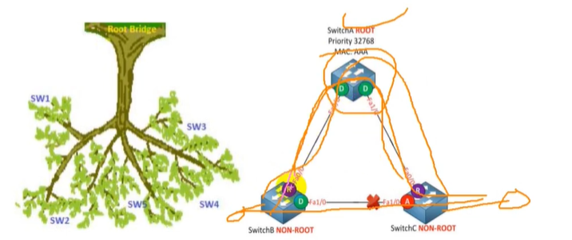

**ROOT BRIDGE:**

* Root Bridge is the starting point of the Spanning Tree Protocol STP network topology.
* STP uses two parameters, bridge priority and MAC addresses of participating switches.
* Every switch port has mac address but a base MAC Address also exist. **Show version.**
* A Cisco Switch that has the lowest bridge priority value, is elected as the root bridge.
* If bridge is same in all switches, switch which has lowest base MAC address is elected.
* By default, the bridge priority or switch priority value is set to 32768 in all Cisco Switches.
* Unless change this value, Switch that has lowest MAC address is elected as Root Bridge.
* If want specific switch to be elected as Root Bridge, can set bridge priority value less than.
* Selection process of the Root Bridge happens each time when a network change occurs.
* Like new switch is added in network topology, or existing switch is removed, or Root failed.

**COMMANDS:**

* **<S2>#show spanning-tree vIan 1** // every individual switch is root bridge itself.
* **<S2>#show spanning-tree summary // every vlan has different blk and shared ports it will shows summary**
* 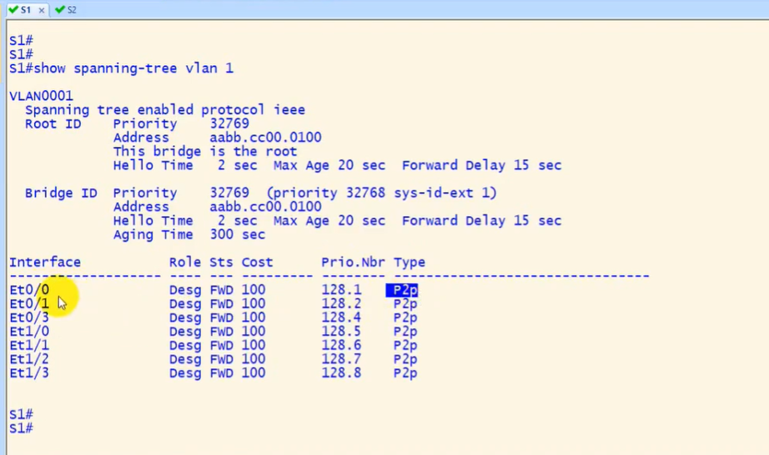



**Non-Root Bridge:**

* Except Root Bridge, all remaining switches of network are considered as Non-Root Bridges.
* Non-Root Bridges receive updates from Root Bridge & update their STP databases relatively.

**Port** **Priority**:

* Each port of a Switch has a Port Priority value associated with it, 128 by default.
* Gi0/1 128.25 P2P: Gi0/1 is the interface 128 is default value and 25 is port number.
* P2P means Point-to-point (Full Duplex) and Shr means Shared (Half Duplex) like hub.

**ROOT BRIDGE / KING SWITCH:**

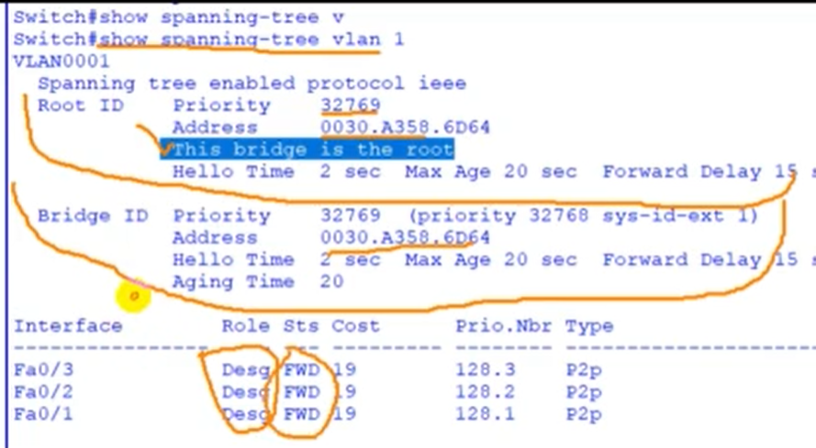

* Role Designation, status Forward

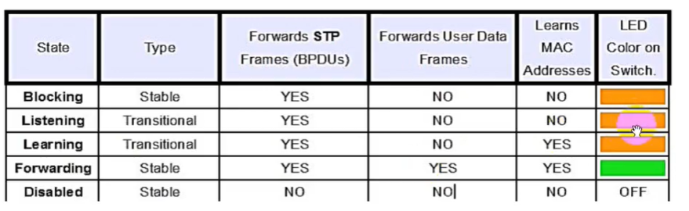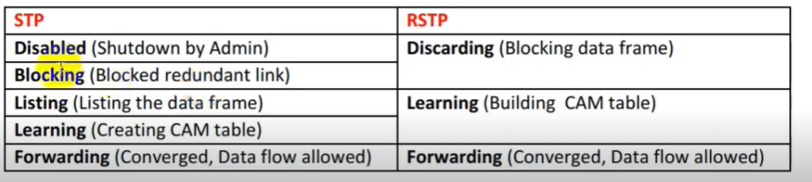

**Spanning Tree Port States:**

* Ports on a switch with enabled STP are in one of these five port states.
* Blocking state, listening state, learning state, Forwarding and Disabled.
* Switch does not enter any of these port states immediately except blocking state.
* When the SW is enabled, every switch in the network starts in the blocking state.
* Spanning Tree Protocol later changes to the listening state and learning states.

**Blocking** **State**:

* When we power on a Switch, the switch puts all of its ports in this state.
* The Switch Ports will go into a blocking state at the time of election process.
* In Blocking state, the switch only listens and processes the BPDUs (bridge protocol data units) only.
* Switch port in blocking state does not participate in frame forwarding.
* Port in blocking state discards frames received from attached network segment.
* During blocking state, port only listening & processing BPDUs on its interfaces.
* After 20 seconds, Switch port changes from the blocking state to listening state.

**Listening State:**

* After blocking state, Root Port or Designated Port will move to listening state.
* All other ports besides root and designated ports will remain in a blocked state.
* During listening state, pot discards frames received from attached network segment.
* During listening state port discards frames switched from another port for forwarding.
* After 15 Seconds; the switch port moves from the listening state to the learning state.

**Forwarding State:**

* In this state, the switch listens and processes both BPDUs and user frames.
* Port in forwarding state forwards frames across attached network segment.
* In forwarding state, port will process BPDUs & update its MAC Address table.
* Data frames are forwarded to destination, Forwarding State is normal state.
* The Data and configuration messages are passed through the port or link.

**Disabled State:**

* A port in the disabled state does not participate in frame forwarding.
* A port in the disabled state does not participate in operation of STP.
* A port in the disabled state is considered non-operational.
* This state applies to all ports which are either manually shut down.
* All unplugged ports or interface also remain in Disabled state.

**Spanning Tree Port Roles:**

**Root Port:**

* For non—root switch, port that connects this switch to the root switch.
* The Root port is the port that directly connects to the Root Bridge
* The Root Port is the port which has least cost to reach root switch.
* The Root port is the port that is closest to the root bridge or root switch.
* Every non-root bridge must have a root port connect to root switch.
* Only one Root Port on non-root Switch and no Root Port in root bridge.
* A Root Port has the least cost from the "Switch" to the Root Bridge.
* The Root ports forward traffic toward the root bridge or Root switch.

**Alternate port:**

* Alternate port is a best alternate path to the root bridge or Switch.
* Alternative port moves to the forwarding state if any change in topology.

**Designated Port:**

* A non — root port, which is forwarding away from the root switch.
* Designated Port has the lowest cost in that Ethernet segment.
* Switch can have multiple designated ports & marked as forwarding port.
* Designated Port has the lowest Path Cost on particular LAN segment.
* In Cisco Switches a Root Port can never be a designated port.
* For root bridges or switch, all switch ports are designated ports.

**Non-Designated Port:**

* Non-designated port having higher port cost than the designated port.
* Spanning Tree Protocol marks non-designated port as the blocking port.
* Non-designated port not forward any frames and used to remove loops.
* If any change in topology, the same port may become a designated port.
* The non-designated port of is a Cisco switch port that is blocked.
* A non-designated port of switch is not a root port or a designated port.

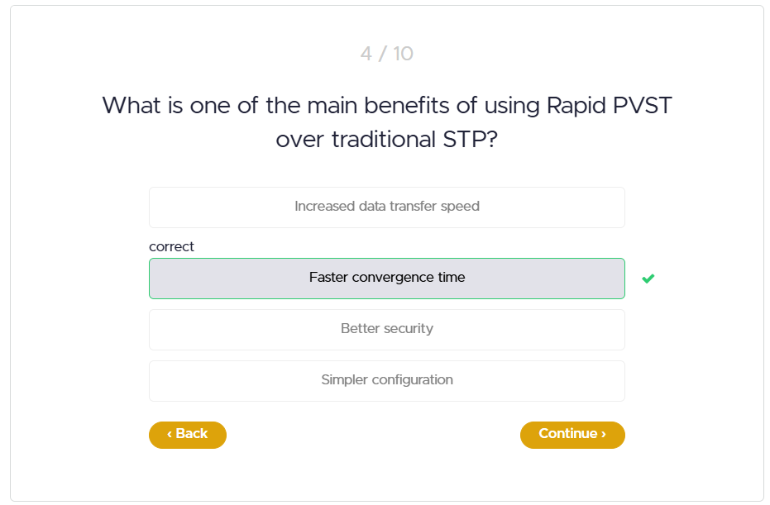

**Configuration Of STP: PVST**

* Non-Root bridge with default root port as e0/0, but forcibly e0/1 is declared as root port by decreasing the cost value.
* **Sw1(config)# interface e0/1 spanning-tree cost 60**

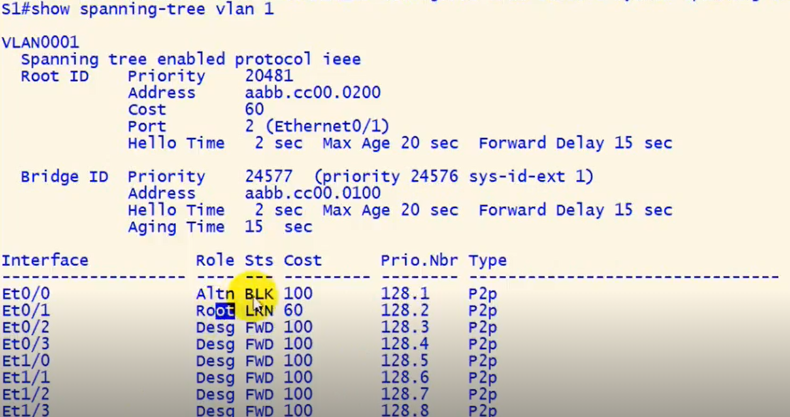

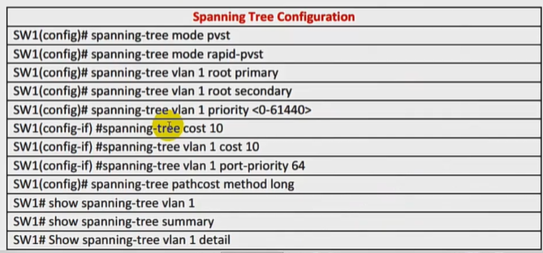

* All commands for configuration of STP.

**Spanning Tree Timers:**

STP timers are hello timer, forward delay timer and max age timer.

**Hello Time:**

* Hello Time, defines interval Root Bridge send out configuration BPDUs.
* 0 The Default Spanning Tree Protocol (STP) hello timer is 2 seconds.
* STP hello timer can be adjust to any value between 1 and 10 seconds.

**Forward Delay:**

* Forward delay timer is time interval spent in listening & learning state.
* The Forward Delay is the length of the Listening and the Learning states.
* Default Spanning Tree Protocol (STP) forward delay timer is 15 seconds.
* STP forward delay timer can be adjust to any value between 4 & 30 seconds.

**Maximum Age:**

* The Spanning Tree Maximum Age timer often referenced as MaxAge.
* The time interval that a Cisco Switch stores a BPDU before discarding it.
* Length of time each Switch save superior BPDU's info before discarding it.

**STP Operation:**

* All the Cisco Switches of the Spanning Tree domain first elect a Root Bridge.
* The root bridge acts as a point of reference for all other switches in the network.
* All ports of the root bridge or root Switch remain in the forwarding mode.
* Once the root bridge is elected, all remaining switches select a single port.
* That has the shortest path cost to reach the root bridge and marked it as root port.
* After selecting root port, switches determine single designated port for each connection.
* If multiple ports or interfaces are connected with the same switch or LAN segment.
* Switch select only one port that has lowest path cost & marks it as the designated port.
* Once the root port & designated ports are selected, the Switch blocks all remaining ports.
* The Switches block all other ports to remove any possible or existing loop from network.

**Root Ports Selection:**

* First of all, the interface that associated to lowest path cost is more preferred.
* Interface associated to lowest system priority of advertising switch is preferred next.
* Port associated to lowest system MAC address of advertising switch is preferred next.
* When multiple links are associated to same switch, lowest port priority is preferred.
* When multiple links are associated to same switch, lower port number is preferred

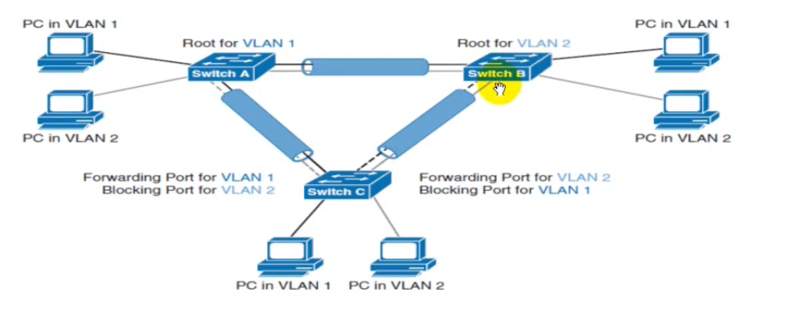

**PortFast:**

* By passing the listening & learning states, go to forwarding mode.
* STP PortFast feature causes a port to enter forwarding state immediately.
* Port Fast port normally connect to end devices such as server, printer or PC.
* Do not enable portfast on an interface to another device which is hub/switch.
* If PortFast feature port connect to a cisco switches, it may cause a loop.
* PVST+, Rapid PVST+, or MSTP Spanning tree all support PortFast feature.
* Port Fast can be enable on interface level or globally on Cisco switch.
* When running globally its enable Portfast on interface that is edge port.
* **“SW1 (config)#spanning-tree portfast edge default”**
* **SW1 (config)# interface rang f0/0-2 spanning-tree portfast**



**Configure EtherChannel:**

* Etherchannel, which is also, known as link aggregation or port channel.
* Etherchannel bundle multiple physical links into a single logical link or port.
* Technique to combine multiple physical link to make a single logical link.
* Etherchannel can be used for load balancing or load sharing & fault tolerance.
* Etherchannel also known as bundling, port channel or EtherChannel bundle.
* EtherChannel or port channel have three modes LACP, PAgP and ON mode.
* Etherchannel Increased bandwidth, increased availability and Load Sharing.
* Etherchannel provide Auto Configuration, Faster convergence & cheaper solution.
* Etherchannel require same duplex, speed, native, allowed VLANs & switchport mode.
* Etherchannel load not equally distributed across all links bundled in Etherchannel.
* In EtherChannel Load balancing is done based on flows, not based on packets.
* By default, Layer 2 packets are distributed on source & destination MAC address
* By default, Layer 3 packets based on source and destination IP address.
* Maximum of eight interfaces can be aggregated to form a single logical link.
* Channel must be made up of minimum two ports and maximum 8 interfaces.
* EtherChannel or Port Channel can be configured either manually or dynamically.
* EtherChannel port groups can be run from Switch-to-Switch or Switch-to-Server.

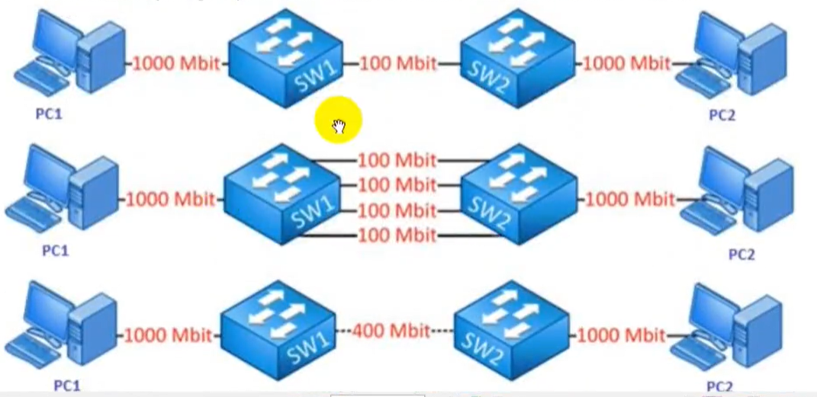

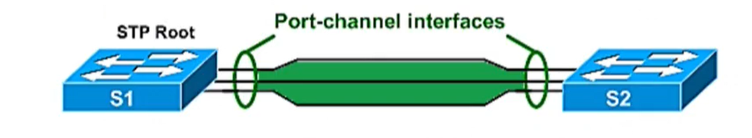

**LACP (Link Aggregation Control Protocol):**

* Link Aggregation Control Protocol is the open standard 802.3ad.
* Combine multiple links into a single logical link to increase bandwidth.
* All links participating in a single logical link must have the same settings.
* All ports participating must have the same speed and duplex configuration.
* All ports participating in single logical link must be in the same VLAN.
* All ports participating in single logical link must be in same operational mode.
* No ports participating in single logical link can have SPAN (switched port analyser) configured.
* Can have up to 16 ports in LÅCP EtherChannel only 8 can be active at one time.
* The LACP protocol can be configured in either passive or active mode.
* In the active mode, the port or interface actively tries to bring up LACP.
* In the passive mode, it does not initiate the negotiation of LACP protocol.
* LACP advertises messages with the multicast MAC address 01:80:C2:00:00:02.

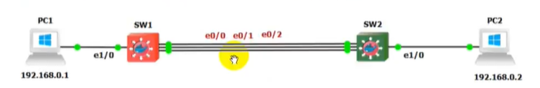

**PAgP (Port Aggregation Protocol):**

* PAgP stand for Port Aggregation Protocol & Cisco proprietary protocol.
* It also creates EtherChannel links and is configured similarly to LACP.
* PAgP automatically configure individual ports into a single logical link.
* There are two modes for the Port Aggregation Protocol (PAgP).
* Auto is the passive negotiating state, which responds to PAgP packets.
* Desirable mode places interface or port into an active negotiating state.
* Having two ends of a PAgP link in auto mode will not result in a PAgP link.
* Because neither side will negotiate to bring up the PAgP EtherChannel.
* PAgP advertises messages with the multicast MAC address 01:80:C2:00:00:02.
* You can have up to eight ports in a single PAgP EtherChannel or logical link.
* All ports in PAgP EtherChannel must have the same speed & duplex settings.

**EtherChannel Static (Manual):**

* Switchports can be configured to bypass LACP or PAgP protocols.
* It is simply changing the mode to ON both sides of the Switches.
* This mode is used to manually configure EtherChannel or Port Channel.
* This mode can be used if device on other end does not support PAgP or LACP.

